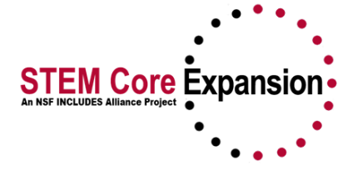
NSF INCLUDES Alliance:
STEM Core Expansion Presentation Handout
Reverse Site Visit, March 6, 2020

STEM Core Team Attendees:
Jim Zoval, PI/Alliance Director, Saddleback College
Janet Yowell, PI, University of Colorado Boulder
David Gruber, Director of Backbone Institute, Growth Sector
Gary Barnak, Project Manager, Saddleback College
Kea Anderson, Evaluator, SRI Education
Jared Lessard, Senior Research and Planning Analyst, Saddleback College

SESSION 1
STEM Core Alliance Overview Presenters: Jim Zoval, David Gruber

The STEM Core shared vision is to create a pathway that brings underrepresented and underprepared students to a skill level required for A.S., B.S., and industry employment in STEM fields.

The general STEM Core goal is to increase diversity and productivity in the Nation's STEM workplace.

The major goals of this NSF INCLUDES STEM Core Alliance are to improve practice related to providing access to STEM education and employment for thousands of underprepared community college students through a networked improvement community approach.

These goals are accomplished/supported using the following five pillars (practices):

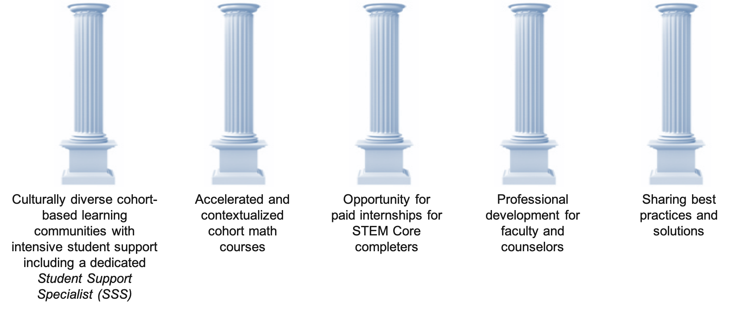
Using the STEM Core Model, we will change people’s lives by changing systems.
- Changing the “college experience” by facilitating a supportive, second family for students
- Changing the way colleges deliver math courses
- Changing the way employers view internships
- Changing the way faculty and counselors view student potential
- Changing students’ learning possibilities through best practices training (e.g., growth vs. fixed mindset).

The STEM Core Model Presenter: David Gruber
Details, Infrastructure, and Partnerships
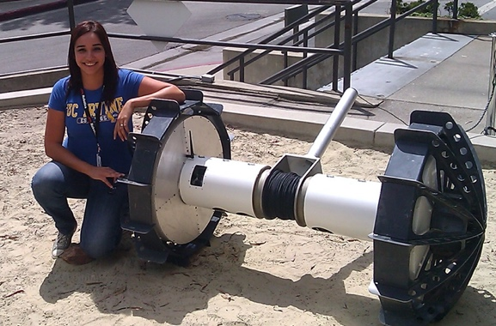

CHALLENGE: There exists a mismatch between expanding engineering and computer science employment and next-generation (community college) workforce pool.

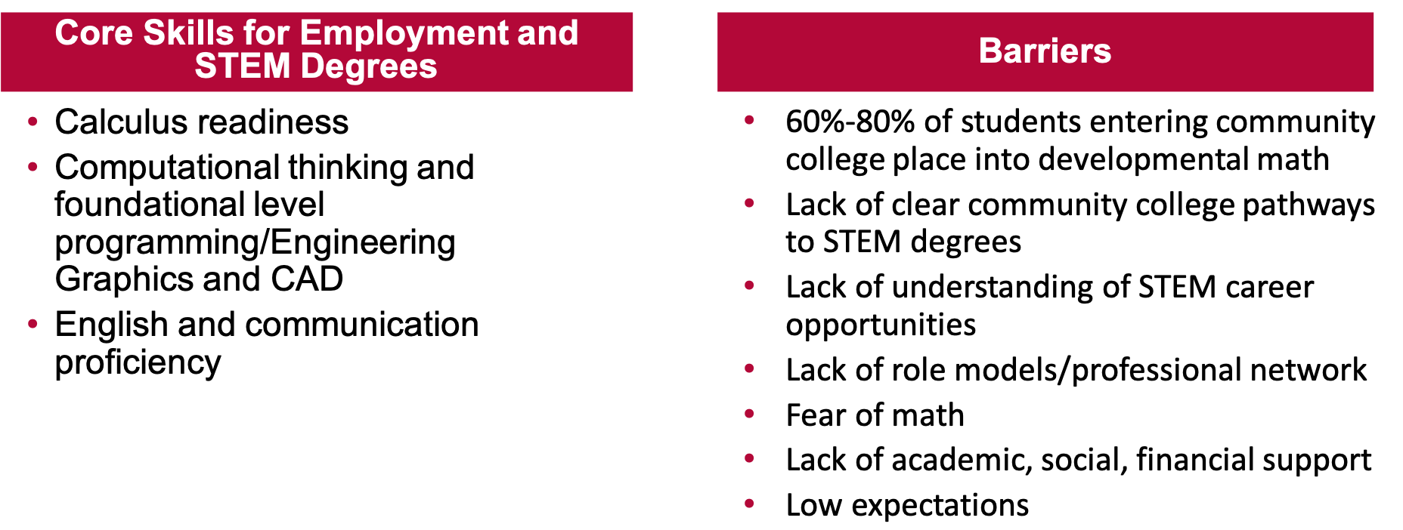STEM Core Strategy
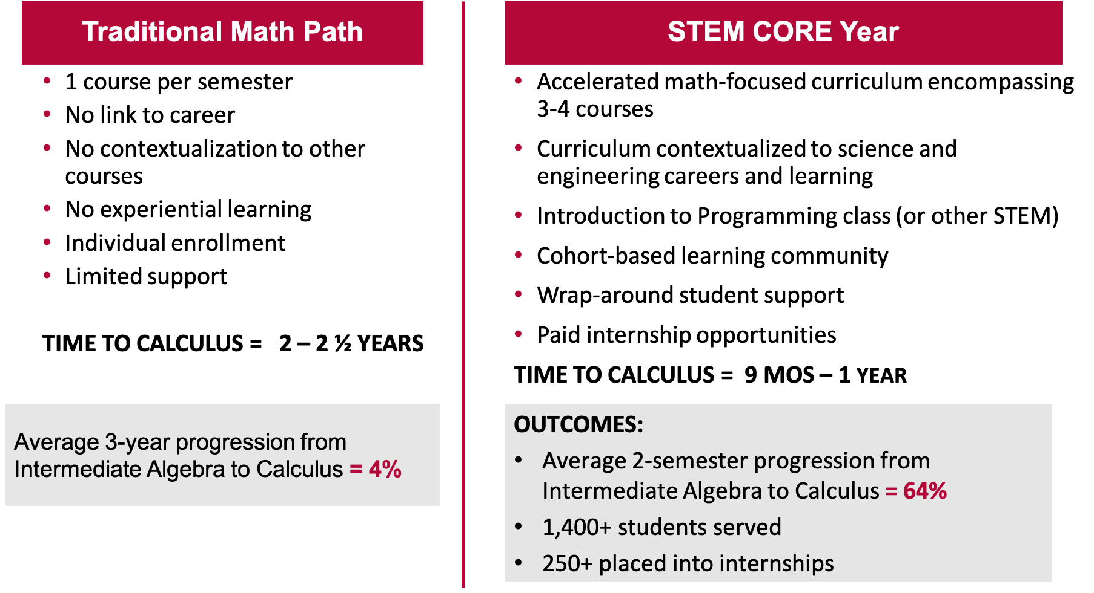

Specific Example of a STEM Core Model Pathway:

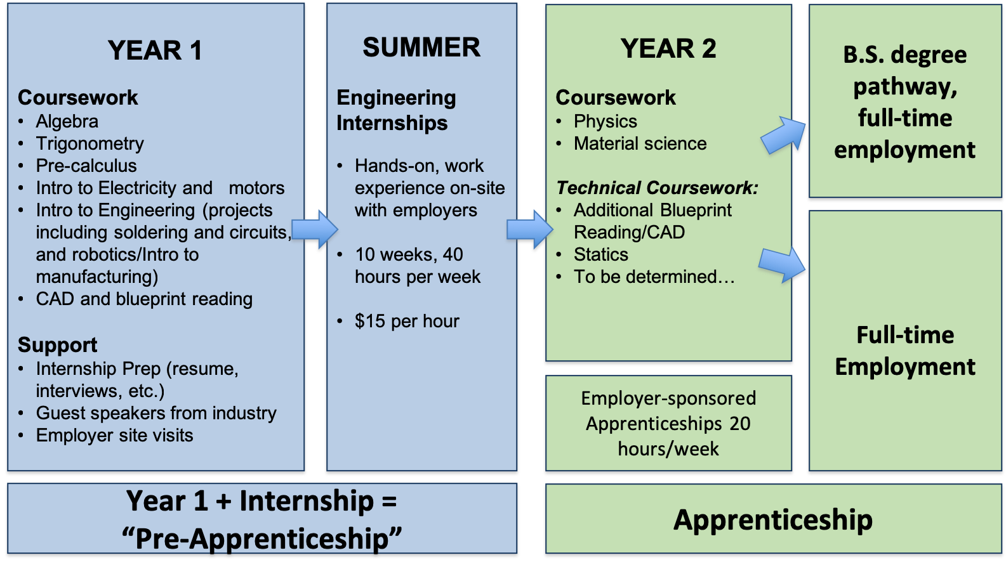

STEM Core Network Employer Partners

- NASA Jet Propulsion Lab
- NASA Ames Research Center
- NASA Goddard
- Lawrence Livermore National Lab (LLNL)
- Lawrence Berkeley National Lab (LBNL)
- Los Alamos National Lab (LANL)
- Sandia National Lab
- Stanford Linear Accelerator Lab (SLAC)
- BD Bio Sciences
- Blach Construction
- California Dept. of Transportation (Caltrans)
- Communications and Power Industries
- Jabil
- Lam Research
- Leidos
- Lockheed Martin
- Malware Bytes
- Mathews Mechanical
- Northrop Grumman
- SAP Software
- Silicon Valley Bank
- Symantec
- TRC Solutions
- VM Ware
- Varian
- Zoox
- Fort Mead Alliance (employer association)
- Silicon Valley Leadership Group (employer association)

STEM Core is currently developing STEM pathways to five national labs: Lawrence Livermore, Sandia, Los Alamos, Stanford Linear Accelerator and Oak Ridge;

Pathways build on STEM Core college and dual credit programs, include visits and presentations, and lead to internships and potential employment in engineering and computer science;

STEM Core is seeking funding support from the Department of Energy to expand this effort including a direct focus on partner minority serving institutions.

National STEM Core Academic Network

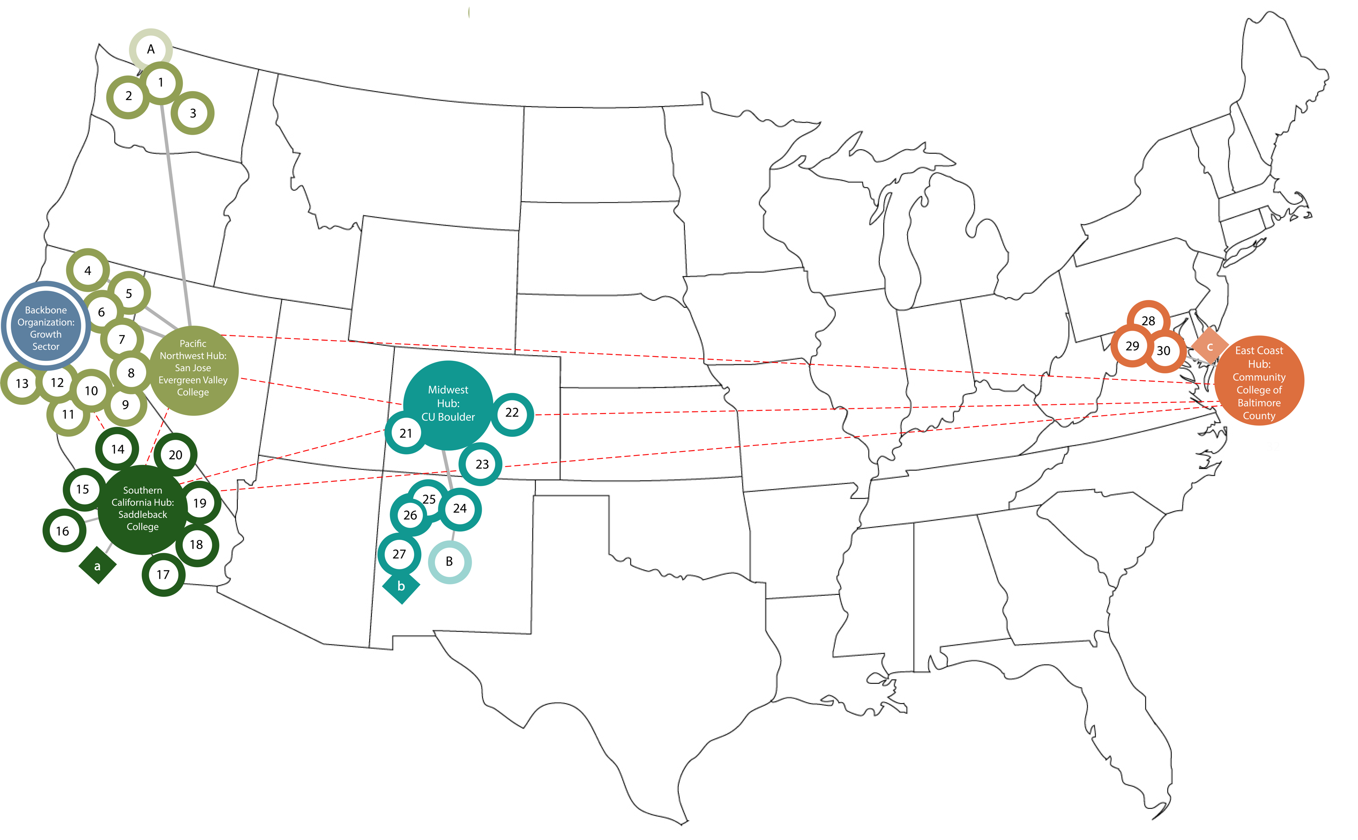
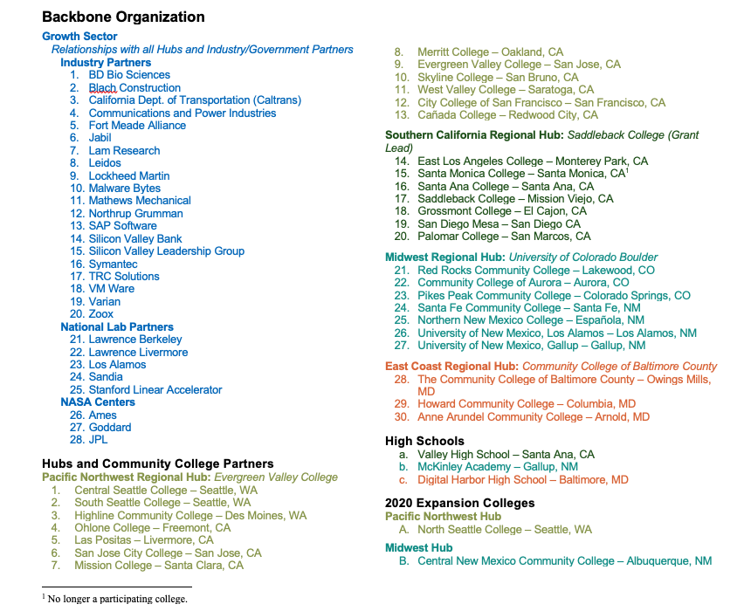

STEM Core Collaborative Infrastructure

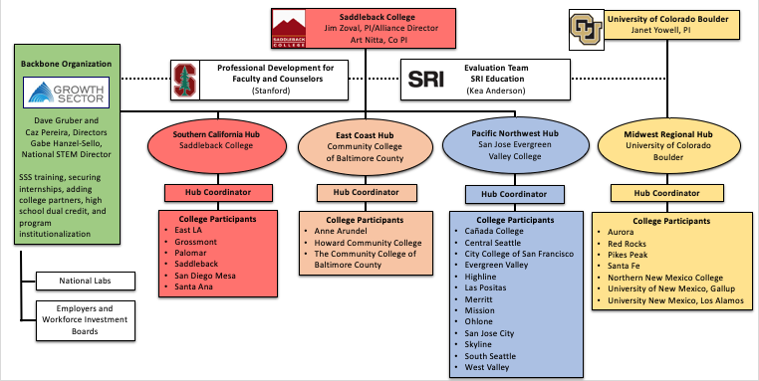

STEM Core Management Structure
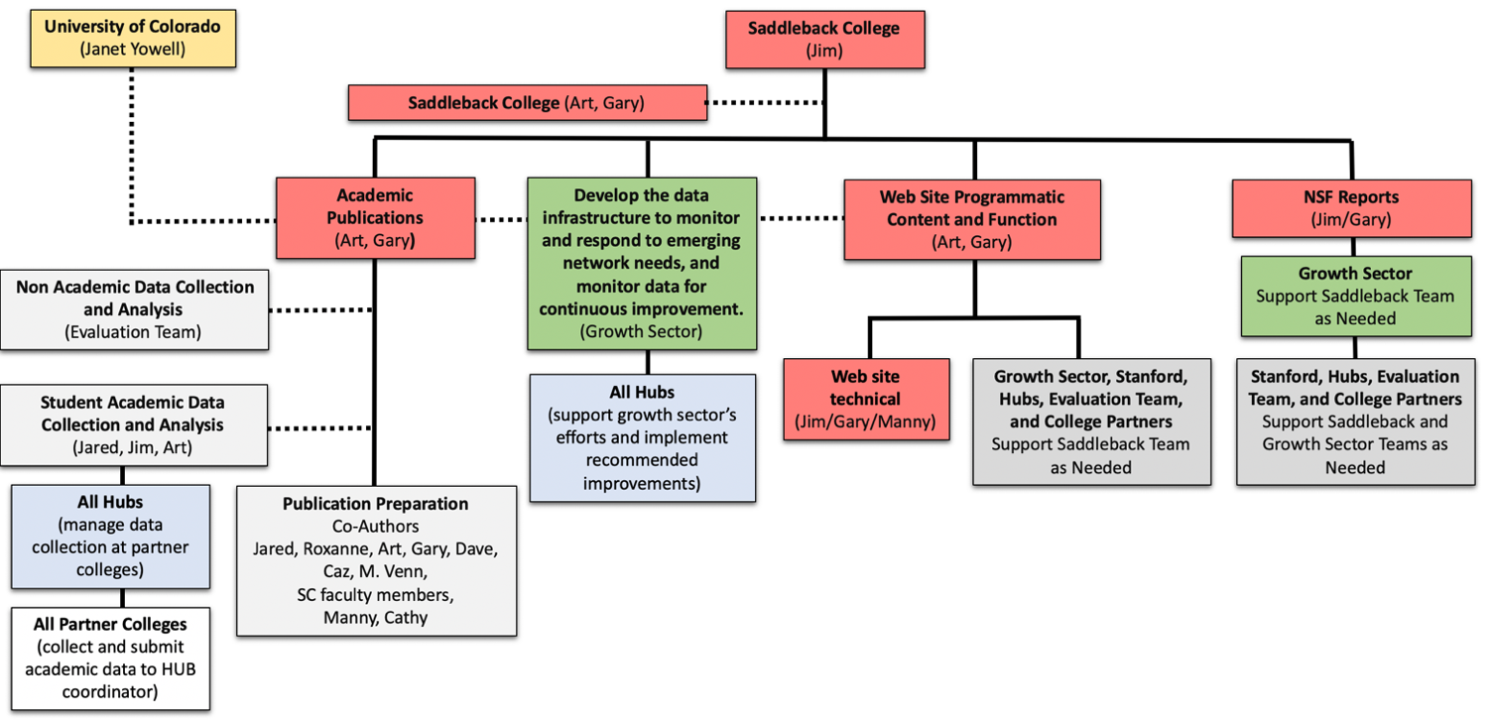
General Programmatic Management Structure

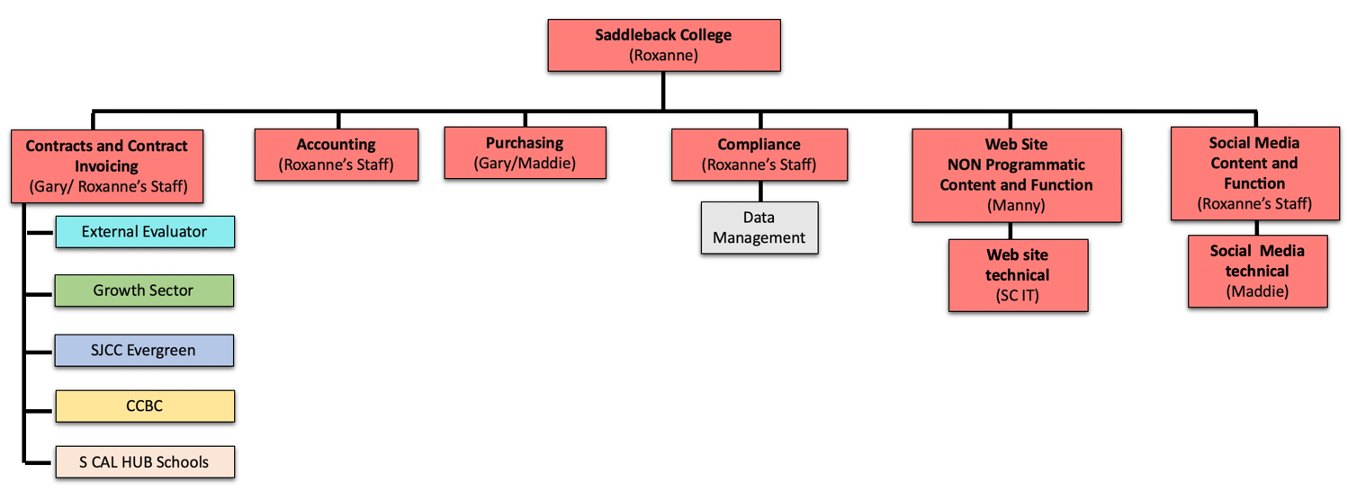
Contracts, Accounting, Invoicing, Purchasing, Public Relations, and Compliance

STEM Core Management Structure (Collaborative Award)
Contracts, Accounting, Invoicing, Purchasing, Public Relations, and Compliance

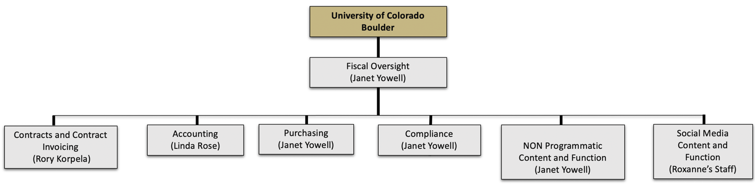

High-Level View of NSF INCLUDES Alliance Stem Core Budget

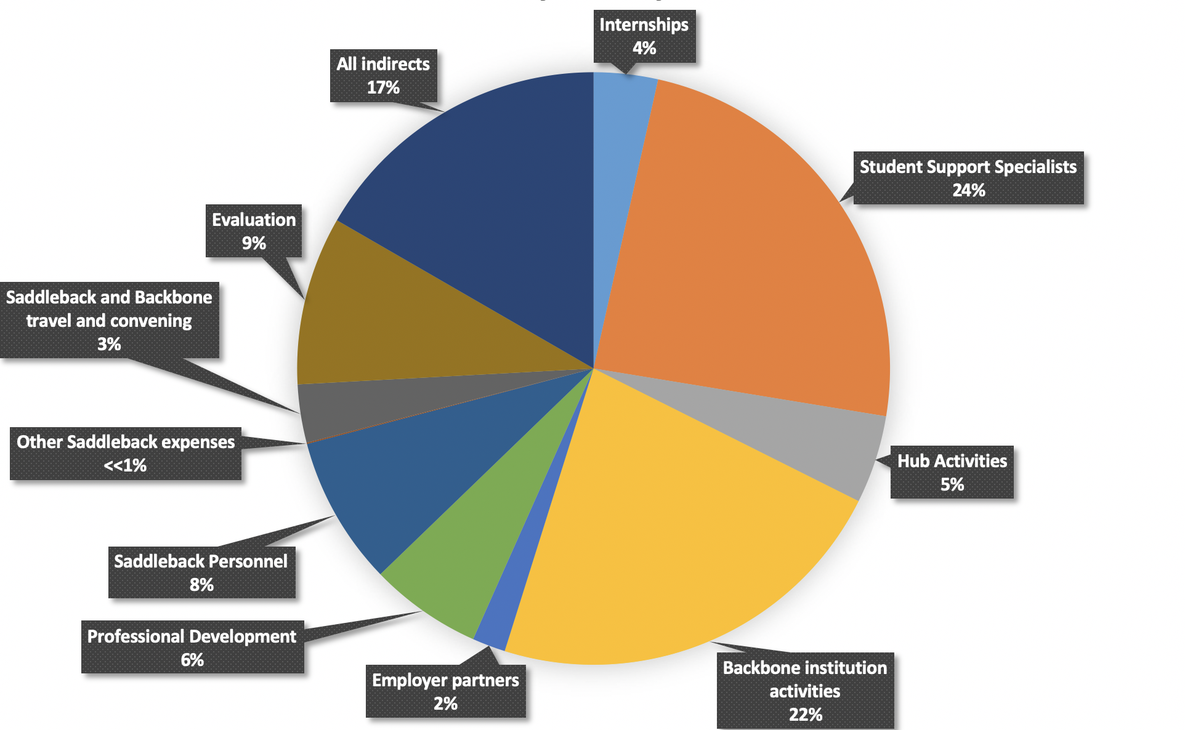

CONCLUSION OF SESSION 1

SESSION 2

Goals, Metrics, and Evaluation Presenters: Jim Zoval, Kea Anderson, Janet Yowell
In the first part of session 2, we will report on progress toward goals and objectives presented in the Alliance strategic plan, logic model, and those that are relative to the intellectual merit and broader impacts of the Alliance. In the second part of session 2, we will discuss evaluation results, outcomes, and accomplishments to date. In both parts we will discuss some plans that have been developed to successfully accomplish future activities.

Goals and Metrics
As mentioned in Session 1, the major goals of this NSF INCLUDES STEM Core Alliance are to improve practice related to providing access to STEM education and employment for thousands of underprepared community college students through a networked improvement community approach.
The specific objectives, activities, and deliverables listed in our strategic plan are divided into four categories:
I) Research and Evaluation
II) Alliance Coordination
III) Alliance Communication
IV) Stem Core Implementation

Handout annotation legend:
* = done and will continue doing
* = not completed yet, but expect to complete in the NSF INCUDES Alliance timeframe
SC = Saddleback College
GS = Growth Sector (our Backbone Institute)
I) Research and Evaluation Presenter: Jim Zoval
Objective/Goal: Collecting data on implementation and student outcomes *
Activities: Saddleback’s Research Director will identify implementation data and student outcome data to be collected and shared for purposes of research on intervention effectiveness and use in the external evaluation of the Alliance (SRI). * GS will work with the coordination hubs and individual colleges as necessary to collect college-level data.* SC will conduct data cleaning and data preparation.*
Deliverable/Metric: Data systems will be in place with clear guidelines regarding data definitions, file formatting and layout, etc.*

EXAMPLE: Collecting data on the number of students served:

Fifteen schools had YR1 STEM Core cohorts with a total of 1,286 students.

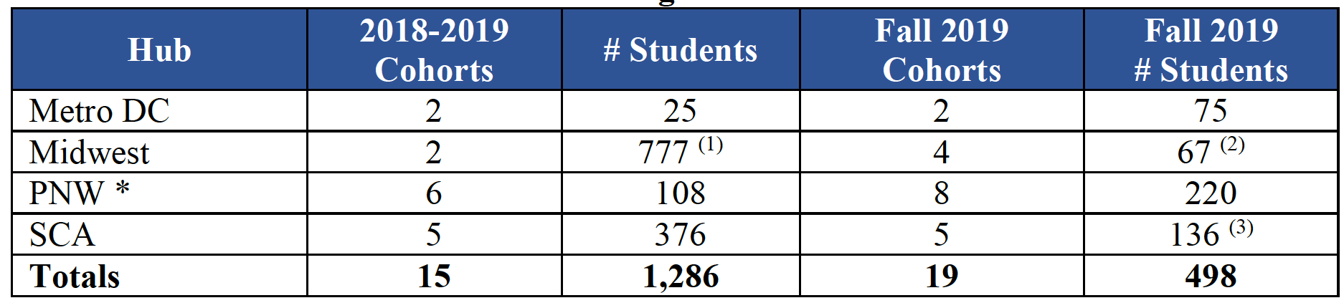
- Not all students were officially “cohorted.” The official STEM Core roll-out will occur in fall 2019 in the Midwest hub. Numbers are included as these schools recognize the STEM Core and have implemented initial programming for a fall 2019 start.
- Midwest hub numbers decreased once formal cohorts were created on Fall 2019 and students elected to become identified as part of the official STEM Core.
- Certain SCA schools are changing their cohort structure. SD Mesa will drop one of two cohorts. Santa Monica’s program has dropped. ELAC and Palomar are running “pilot” programs this year. Grossmont will likely start in spring 2020 semester.
* Las Positas College data not included.

EXAMPLE: Network wide collecting of student demographics.
Network-wide template sent to partner colleges for collection of demographics:

Demographic Results to Date:
- Women 36%
- Students of Color 47%
- Economically Disadvantaged (Pell Grant Eligible, YR 2) 52%

EXAMPLE: Network-wide collection of student calculus readiness.

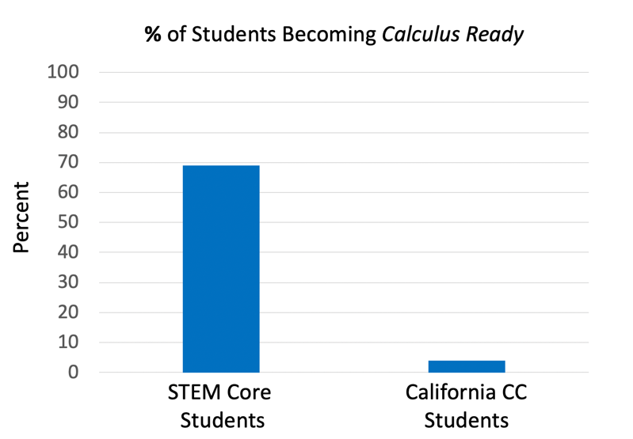
69% of our STEM Core student participants became calculus ready in the first year of the Alliance Program. That value can be compared to only 4% of remedial California CC students (CCCCO Data Mart) become calculus ready within their entire stay at the CC level.

EXAMPLE: Ohlone College (2015-2019) math course success rates
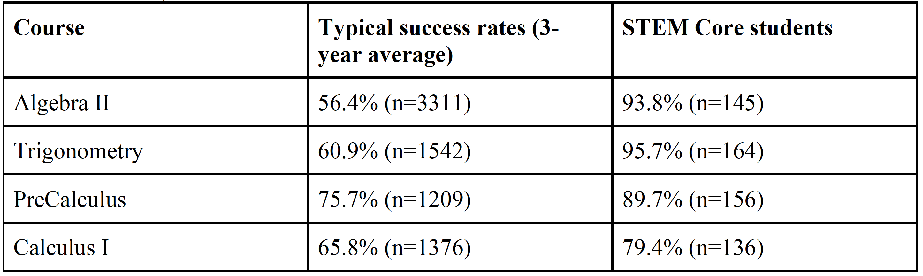
Preliminary Ohlone College data also shows that success rates, while still high (40%), decrease for courses that come after the program (calculus II).
The data also shows that STEM Core students who are not successful in their first attempt at Calculus II are taking the course again.
- For example, in one cohort, 76% of the STEM Core students who completed Calculus I also completed Calculus II, but some required multiple attempts.
EXAMPLE: Collection of student academic data including propensity matching comparison
Propensity matching parameters used for our comparison group are: ethnicity, gender, Pell grant eligibility, intended major, math course taken below transfer level (y/n), co-requisite math course required (y/n), and high school GPA. These are parameters that have been shown to correlate with student achievement. The results of the Saddleback Student analysis are discussed below. In the second quarter of this year, we requested data from two California partner colleges (San Diego Mesa and Ohlone) and a non-California partner college (CCBC) in order to see how it is received/implemented. This will be followed by a nationwide partner college data request.
Student Academic Data Analysis for Saddleback Fall 2017 and Fall 2018 INCLUDES Students
Differences in covariates between INCLUDES and non-INCLUDES students before and after propensity score matching:

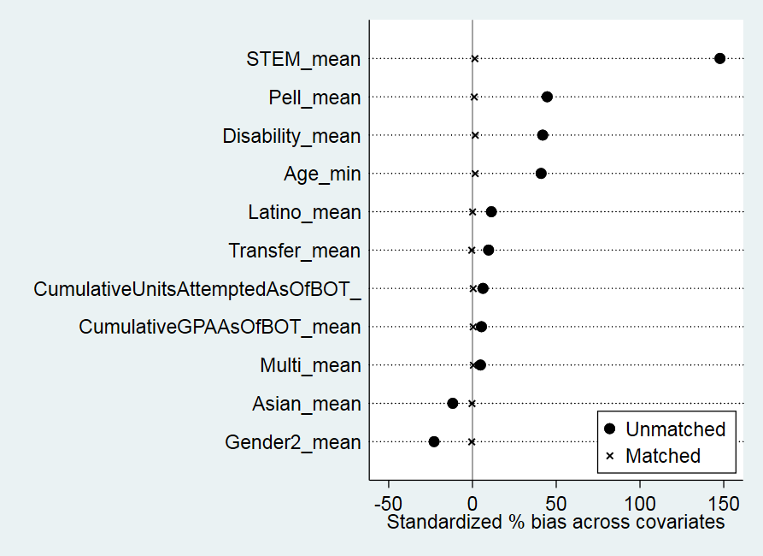

Academic Data Analysis Summary: INCLUDES cohort students, including females, Latinos, and economically-disadvantaged students, were more than 5 times more likely to become calculus-ready than were propensity score matched non-cohort students. These same INCLUDES cohort students had higher math course grades than did propensity score matched non-cohort students.

EXAMPLE: Collection of data on participation in internships
The following placements were made for summer 2019 internships:
  - SLAC National Accelerator: 16 interns (12 Ohlone, 2 Mission, 2 Skyline)
  - Lawrence Livermore National Lab: 12 interns, (10 Las Positas, 2 Ohlone)
  - Northrop Grumman*: 10 interns (5 Santa Ana, 5 Saddleback)
  - UC Berkeley Transfer to Excellence Research Program: 1 intern (Skyline)
  - Lam Research: 2 interns (Ohlone and Las Positas)
  - City of Pleasanton, City Planning Office (Civil Engineering): 1 intern (Ohlone)
  - Varian Medical Systems: 1 (Ohlone)
  - Silicon Valley Bank (Cybersecurity): 1 (San Jose City College)
  - MECU Credit Union: 1 (CCBC)
  - Modus: 1 (Las Positas)
  - Hathaway Dinwiddie: 1 (Las Positas)
Total 2019: 47 internships
* Northrop Grumman extended offers for continued employment to all ten interns.

Objective/Goal: Implementation Analysis and Learning to Improve*
Activities: Using the Alliance data, backbone Growth Sector (GS) and regional hubs will engage in Plan-Do- Study-Act work to ensure data regarding STEM Core outcomes (e.g. minority representation, math achievement, degree attainment, and participation in internships) in discussed to inform implementation improvements and model improvement*. Annual convening break-out sessions to share data and discuss how the data can be used to inform improvement*.
Deliverables: White papers,* STEM Core website*, conference presentations,* and published research papers.*

EXAMPLES of “Plan-Do-Study-Act” (Continuous Improvement):
- STEM Core Annual National Convening improvement using evaluation survey data
- Student Support Specialist professional development using student survey data
- Math/Science instructor professional development using student survey data

Objective/Goal: Implementation of an External Evaluation*
Activity: Using the data from the previously mentioned goals/objectives and data from additional sources, SRI will evaluate:
1) Variation across regional implementations*
2) The continuous improvement processes*
3) Development of scale*
Deliverables: Quarterly debriefs where the backbone and hub leads will provide formative feedback.* Activities and findings are shared with National Coordination Hub*, the NSF INCLUDES community,* and a researcher conference.*
Kea Anderson, our Evaluation Team Lead, will discuss the project evaluation progress at the end of this session.
II) Alliance Coordination Presenter: Jim Zoval
Objective/Goal: Implementation of Organizational Activities*
Activities: SC develops contracts based upon letters of commitment and support*. SC coordinates procurement and contracting with subrecipients and contractors*. SC develops operational protocols and management systems*.
Deliverables: Partner contracts in place by the end of Year 1*.
Subrecipient monitoring procedures are in place*.
SC holds monthly operational meetings*.
Objective/Goal: Implementation of Backbone Activities*
Activities: Growth Sector engages with hubs to plan professional development, coordinate regional meetings.* Assist with planning and implementation.* Outreach and presentation of STEM Core Model to additional community colleges.* Employer partner development. Dissemination and coordination with the national hub.*
Deliverables: Annual national convenings are held with 100-150 participants per year*.
One new region and three new community colleges per year consider implementation of the STEM Core model*.
III) Alliance Communication Presenter: Janet Yowell
Objective/Goal: Distribution of Materials and Information*
Activities: SC develops Alliance website*, information and document repository*, implements a project management system (basecamp) *, and collaborates with all partners to ensure they have access to information and are able to contribute meaningfully to Alliance dialogue*.
Deliverables: Monthly operational meetings*
Quarterly regional PD or other meetings*
Materials and Information
  - STEM Core Expansion Website: https://www.stemcore.org/
  - STEM Core Backbone Website: http://growthsector.org/thestemcorenetwork/
  - San Jose Community College Center for Economic Mobility (CCCEM): https://econmobility.org/
  - Stanford Educational Leadership Initiate (SELI) : https://seli.stanford.edu/strengthening-stem-core-pathways-tech
Information and Document Repository
- STEM Core Expansion Basecamp Site: https://3.basecamp.com/4164215/projects
    - Document and File Folder: https://3.basecamp.com/4164215/buckets/10714718/vaults/1559850126
- Instagram: @stemcoreexpansion
- Facebook: STEM Core Expansion
Objective/Goal: Implementation of Alliance Meetings*
Activities: GS works with partners to schedule regional activities and annual convenings*.
Deliverables: Quarterly regional PD or other meetings*
Annual convenings are hosted by a different regional hub each year*.
Alliance Meetings (Internal)
  - Alliance Stakeholders – Quarterly check-ins
  - Saddleback College – Weekly PI and support staff meetings
  - CU Boulder – Weekly check-ins with backbone and Saddleback PI
  - Hubs (PNW / SCA / Midwest / Metro DC) – Quarterly meetings with area partner schools with PD components
  - PI Check-ins – Weekly phone contact with backbone (Growth Sector) and CU Boulder
Alliance Meetings (External)
  - Annual Convening (to be rotated through the Alliance hub areas)
    - YR1 at Stanford Linear Accelerator (SLAC) – 120 attendees (03/19)
    - YR2 at CU Boulder (04/20)
  - Employer Meetings / Growth Sector (partial list that includes project sponsorship, paid internships, other support)
    - DOE / National Laboratories including Los Alamos, Sandia, Lawrence Livermore, Stanford Linear Accelerator, National Renewable Energy, Savannah River, Oak Ridge, and Idaho National Lab
    - NASA sites including JPL, NASA Goddard, and Ames Research
    - Northrop Grumman, Lockheed Martin, Caltrans, TRC Solutions, HNTB Corp., Varian Medical Systems, WHM Corp., and Tesla
  - Employer Consortium Partners (Growth Sector)
    - Silicon Valley Group and Ft. Meade Alliance
  - Sustainability (Growth Sector)
    - Chase Manhattan, Milken Institute, and Irvine Foundation
    - DOE and several individual National Labs (see above)
  - Expansion (Growth Sector)
    - Various schools in all Hubs
Student Support Specialist Professional Development Events
  - Quarterly Hub Meetings (supported by backbone Growth Sector) – recruitment, internship prep, cohort building, best practices, scholarship application, student tracking, and evaluation needs
  - YR1 National Convening - Mentorship in Student Persistence
  - Materials (SSS and Faculty Professional Developement
    - YouCubed framework PD materials (Google Drive)
    - SSS training materials by Growth Sector – outreach, recruitment, student contact, and workshop content (Google Drive)
    - Spring 2020 Workshop Resources - https://drive.google.com/drive/folders/1lpG1OKyJ-OgFiJ7B8oF1QzDBBWnhC7R4
    - STEM Core Program Materials - https://drive.google.com/drive/folders/1OIX18Wor2xvwsY_wDaDM9wR_uinrZ73y

Objective/Goal: Implantation of Hub Coordination*
Activities: Hubs support college implementation and participation in PD and other networking opportunities*
Deliverable: PI meeting discussions (Changed to: Hub Coordinators provide HUB activity quarterly reports to PI*)
IV) STEM Core Implementation Presenter: Janet Yowell
Objective/Goal: Provide Support for the Model*
Activities: GS and Coordination Hubs provide individual college-level support for model implementation as necessary*. GS trains and coordinates the work of all student support specialists*.
Deliverables: Implementation of objective's activities is complete or ongoing*
Trained student support specialists manage all STEM Core cohorts*
Hub Coordination Details
- The Alliance consists of four regional hubs; PNW covering Northern California and Washington; SCA covering Los Angeles, Orange, and San Diego Counties; Midwest covering Colorado and New Mexico; and Metro DC with Maryland schools.
  - Hub quarterly meeting are conducted by each hub’s coordinator
  - Hub PD is developed and or delivered by Growth Sector or Stanford
  - Hubs report to the PI quarterly to meet the programmatic and fiscal NSF report requirements
- Growth Sector in San Francisco provides overall Alliance support as the backbone organization.
  - Includes PD
  - Includes Alliance expansion
  - Includes paid internship opportunities for cohort students
  - Includes sustainability strategies
- SRI Education provides external evaluation support for the Alliance.
- Hubs support college implementation and participation in PD and other networking opportunities

Objective/Goal: Implementation of Professional Development Programs*
Activity: SJECCD’s Center for Economic Mobility and Stanford’s youcubed program provide professional development for faculty and counselors*
Deliverable: Sixty faculty and counselors participate in professional development in Year 1*, 100 in Year 2, and 200 per year in each subsequent year.
Faculty and/or Counseling Support Specialist Professional Development Events
  - YR1 National Convening (03/19)
  - Stanford and Stanford YouCubed / Confronting low institutional expectations through professional development intervention
  - UT Dana Center / Scaling and Contextualizing Math for Engineering and Computer Science in Washington, California, and Colorado
  - YR2 National Convening (04/30) – UT Dana Center / Redesigning the Pathway to Calculus
  - Stanford Graduate School of Education / Saddleback College (01/20) workshop / Language, Culture and Science: Technology as The Cultural Bridge for STEM Learning
  - California CMC³ South (10/19) – Saddleback College / Creating a more Student-Centered Classroom in the Era of AB 705
  - Faculty Collaboration webinar by Growth Sector
  - Midwest Hub partners / UT Austin’s Dana Center workshop / Effective Math Pedagogy for Developmental Students

Progress to date relative to the Intellectual Merit and Broader Impacts of the Alliance
Footnote legend for the annotation of the STEM Core Logic Model Intellectual Merit and Broader Impacts Statements:
* = done and will continue doing
* = not completed yet, but expect to complete in the NSF INCUDES Alliance timeframe

Annotated STEM Core Logic Model: 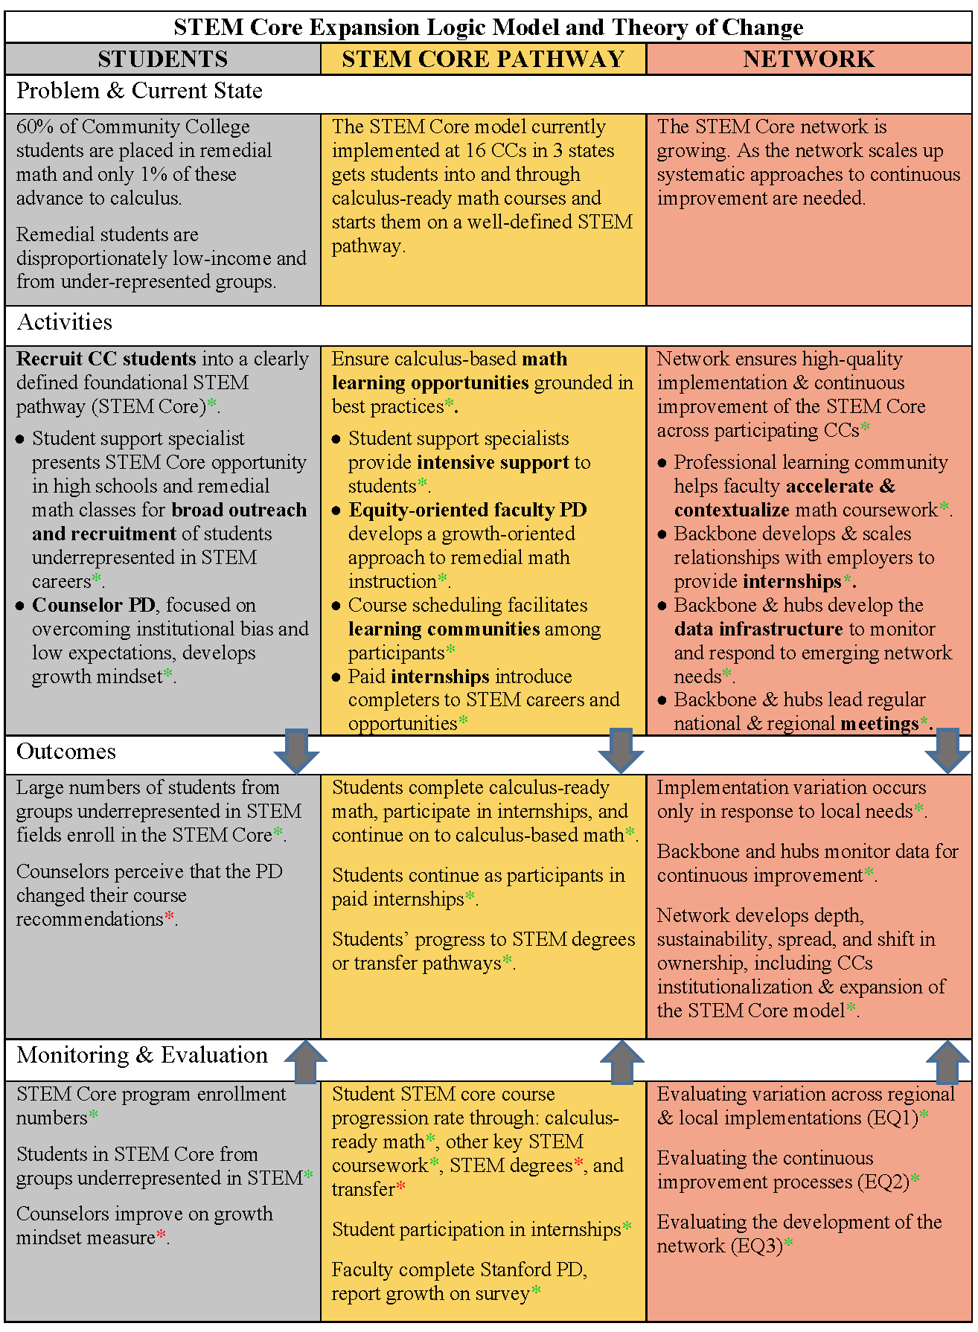
Annotated Intellectual Merit and Broader Impacts Statement:

Intellectual Merit:
The STEM Core Expansion Alliance is founded in collaborative change theory and documented best practice. A successful DDLP will be expanded to 15 new colleges* where it will represent a new learning approach for remedial students with national policy implications. The Alliance will advance knowledge and provide a fertile environment for additional research related to mathematics instruction* and acceleration,* bias and low expectations,* growth mindset,* workforce preparation,* outreach to minority and underrepresented populations,* networked improvement communities,* and partnership development.* As the STEM Core expands, the model will continue to be evaluated to assess its impact on broadening participation in STEM.*
Broader Impacts:
The nation's community colleges, with 7.2 million enrolled students, represent a diverse pool of next generation STEM workers. The STEM Core Expansion Alliance will provide access to STEM pathways for remedial students,* disproportionately from underrepresented groups,* and will thereby increase the diversity and size of the pool of CC students advancing to calculus and promote high-growth, high-wage STEM career opportunities. The Alliance will seek to broaden participation through four levels of action:
    - Student — building on pilot program success, the Alliance intends to engage nearly 5000 remedial students in 30 community colleges over the next 5 years;*
    - Institutional — the Alliance will promote expansion of the STEM Core model at partner colleges through shared data*, professional development* and technical assistance*;
    - Regional — through the hub structure providing coordination*, support and dissemination*, additional colleges* and employers* will be incorporated into the Alliance; and
    - National — through convenings*, collaboration with the national hub* and dissemination beyond targeted regions*, the Alliance will recruit partners at the national scale*.
Evaluation Presenter: Kea Anderson
External Evaluation Goals and Audiences
- Provide the STEM Core Alliance formative and summative feedback on implementation, scale, and continuous improvement strategies
- Share approach and findings with the NSF INCLUDES National Network and field
- Inform policymakers and community college leaders on strategies for preparing more students to meet state and regional workforce needs
- Inform industry leaders on designing successful internship programs to improve equity and diversify workforce
Evaluation Questions
- What supports, constraints, and variation exist in STEM Core community college partners?
- Student demographics, student academic and internship outcomes
- Presence and nature of STEM Core model elements
- Presence of non-STEM Core resources to support implementation, e.g., funding, partnerships
- Role of respective Hubs in supporting implementation

- To what extent does the STEM Core model develop to its intended scale (e.g., depth, sustainability, spread, and shift in ownership)? What resources, supports, and conditions facilitate these shifts?
- PD principles reflected in faculty, counselor, and student support specialist attitudes and practices
- Degree to which STEM Core model is institutionalized at participating community colleges
- Degree to which participating community colleges take ownership, sustain the model over time
- Does the STEM Core network continuously improve to adapt to the needs of the growing community of network members?
- Network leadership strategies by Alliance, hubs, other emerging leaders
- Nature of network node contributions
- Use of improvement infrastructure, e.g., meetings, Basecamp
- Changes in implementation/strategy resulting from improvement cycles
Data Sources
- Student Support Specialist survey
- Student outcomes data
- PD participant survey
- Convening participant survey
- Literature and document review
- Interviews
- Observations
Status of Data Collection and Analysis
- Analyzed Annual Convening participant survey data
- Completed 31 interviews, most conducted during 5 site visits
- Completed observations during site visits, of hub meetings, PD events, and Convening
Developing a Detailed Evaluation Plan
- Confirming sites and participants
- Understanding implementation stages to inform site visit sampling strategy
- Identifying interview sample criteria, subset of annual interviews
- Reviewing protocols
Opening Stronger Lines of Communication
Interdependence calls for close collaboration between Alliance and evaluation.
Collaborating to clarify…
- Alliance information needs and most helpful types of formative feedback
- Deliverable formats and deadlines align with needs

Preliminary Findings: Implementation Variation
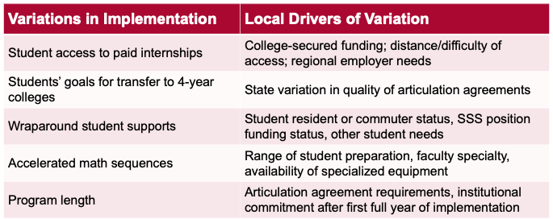

Preliminary findings: NIC
2019 Annual Convening: Observation
- High participant engagement, appreciation for in-person gathering
- Networking across nodes in various hubs, sharing of implementation strategies, resources, and ideas
- Interest in improving access to internships through relationship-building, identifying needed skills
2019 Annual Convening: Survey Analysis
- Participant goal: learn best practices for supporting SC students, network with industry partners and peers
- Challenges noted by administrators: funding, recruiting students, access to internships
- Challenges noted by faculty: inadequate time, recruiting and retention, developing working relationship with Student Support Specialists
STEM Core Significant Barriers and Challenges Presenter: Jim Zoval
- Funding Student Support Specialists
- Funding Paid Student Internships
- Obtaining Deidentified Student Academic Data from Some Partner Colleges
- Post Community College Participant Data Tracking

CONCLUSION OF SESSION 2

SESSION 3
Connecting to the National Network Presenter: Jim Zoval, David Gruber
Building and strengthening capacity for leadership and communication among collaborating organizations and individuals
- Contributed to the Journey to an Alliance webinar series hosted by the Coordination Hub for all Network members (March 26, 2019)
- STEM Core evaluators participate in the Network’s Evaluation Affinity Group and have exchanged resources and best practices, for example those related to developing theories of change for complex networked endeavors
- STEM Core coordinated with Coordination Hub team to identify NSF INCLUDES DDLPs and others whose work intersects with STEM Core’s model for possible invitations to the 2020 STEM Core Network Convening.
- Attended the Network kick-off meeting at NSF (October 3, 2018), where the team mapped Network assets and engaged with other Alliances and NSF
- Met with Alliance leadership at the National Network Convening, resulting in new partnership with SF State.
- Participating in regular calls and online group for Alliance backbone leadership
- Participating in bimonthly calls and new online group of Alliance leaders
How the Alliance connects and contributes to the Coordination Hub and the National Network, and vice-versa
- STEM Core Sr. Personnel participated in the Network’s STEM Pathways Affinity Group and have discussed resources and best practices.
- STEM Core Sr. Personnel attended the 2019 National Network Convening (May 28-29, 2019), where team members engaged with other grantees and funders, met with Alliance leadership, and continued conversations around shared measures. As a result of those conversations, STEM Core developed a new partnership with CAHSI Alliance partner San Francisco State University.
- Meet monthly with a Hub team Alliance liaison (Hub Deputy Director) to discuss results and plans. STEM Core Sr. Personnel provide Coordination Hub with reporting and communications products so Coordination Hub can help share STEM Core results across the Network and via Twitter on @INCLUDESHub.
- Secured introduction from Coordination Hub team and met with Indigenous STEM Affinity Group leaders David Mays and Timberley Roane to discuss supporting Native students’ STEM trajectories (September 2019).
How and where outcomes have been or will be disseminated
- Met with the Coordination Hub team to review and discuss STEM Core outcomes in order to inform the Hub’s planning related to the Network’s shared measures framework (May 2019)
- Provided a STEM Core outcomes document to the Coordination Hub in order to help build the Network’s shared measures framework
- Contributed a blog post to the National Network website about its 2019 National Convening (posted on INCLUDESNetwork.org April 8, 2019)
- Provided permission for STEM Core video to be featured on Network website and in other Hub-led engagement campaigns
- Worked with the Hub team to feature an anecdote about new STEM Core partnerships with New Mexico high schools, colleges, and NM- and CA-based National Laboratories in the “Stories from Across the National Network” document prepared for a Dec 2, 2019 meeting with NSF Director Dr. France Còrdova
- Shared materials with Coordination Hub about paid internships program for them to use in discussions with DC-area industry connections
Plans for future activities, with specific emphasis on efforts to achieve the long-term sustainability of this investment
- Growth Sector is partnering with DDLP recipient North Carolina A+T (NCAT) in expanding the STEM Core model to NCAT feeders Forsythe Community College and Guilford Community College.
  - Goal is to expand the pool of developmental students pursuing engineering degrees at NCAT through an integrated work learning program combining pursuit of a B.S. pathway with paid internships.
  - Part of a larger initiative sponsored by the Department of Energy National Nuclear Security Administration (NNSA) to expand the pool of students at minority serving institutions pursuing careers in engineering and computer science at NNSA labs.
  - Other partners include New Mexico State University, Navajo Tech, Dona Ana and Central New Mexico community colleges, and Los Alamos, Sandia, and Oak Ridge national labs.
- Accepted invitation to give a keynote talk at First 2 Network Alliances May 12-13 Event

STEM Core’s Own Network Communication
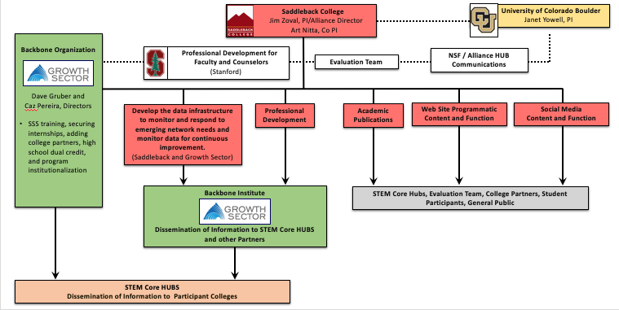

Supplemental Videos:
- Growth Mindset vs. Fixed Mindset: https://www.youtube.com/watch?v=KUWn_TJTrnU

- A Student’s Story: https://www.youtube.com/watch?v=B0Iv7uZsb48
- When this student was in our program, the program was called "Bridge to Engineering"

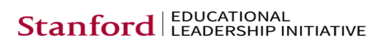

This material is supported by NSF Cooperative Grants #HRD-1834628 and #HRD-1834608. Any opinions, findings, and conclusions or recommendations expressed in this material are those of the author(s) and do not necessarily reflect the views of the National Science Foundation.

